Are you now hosting video interviews? Read our best tips on how to run them successfully
Covid 19 has impacted every spectrum of our lives. As we move forward businesses are having to adapt and reengineer their processes and procedures.
To highlight the level of change conducted by business, consider this. On March 23 the first day of lockdown in the UK it was reported by Apptopia that the conference app Zoom was downloaded 2.13million times around the world. Two months previously the daily down rate was 56,000. Clearly, business operations are changing and being challenged.
https://www.theguardian.com/technology/2020/mar/31/zoom-booms-as-demand-for-video-conferencing-tech-grows-in-coronavirus-outbreak
Recruitment is no different. Businesses still need to hire new staff. But they are having to adapt and change their hiring processes in the face of these new challenges and increasingly they are turning to video-based interviewing.
But moving from a traditional in office person to person interviewing process to one where you are having to embrace the use of video is not easy. Like most change it needs thought and consideration.
Benefits and challenges
Video interviewing has its advantages. It is quicker to arrange and brings more flexibility. It can allow the screening of more candidates in shorter time. It opens the potential for more interviewers to attend and engage in the process. Interviewees have reduced travel costs as well as increased convenience for attendance.
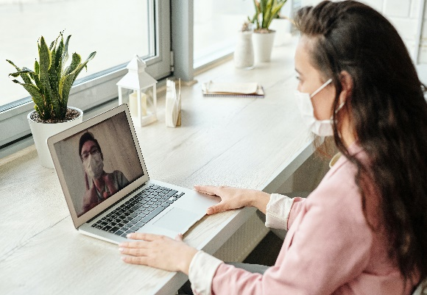
But it also brings some challenges. The use of video places more emphasis on the planning and preparation of interviews. It will highlight areas where that planning and preparation are falling short.
Often discussions on video interviewing focus on the interviewee. How they should prepare and present themselves on the call. But in this new world we should not forget that employers and the interviewers are new to this technology. To ensure employers receive the positive outcomes they are looking for they too need guidance and to build new procedures on this new way of working.
The good news is that many of the traditional preparation methods we used for face to face interviews are relevant in the world of video interviewing. But the new medium does bring some added requirements.
So, what are these additional requirements that you need to take as an employer to ensure both a positive experience and a successful outcome?

Before the call
One of the difficulties that Video interviewing presents is the ability for you to share your companies’ culture. It is much harder for you to share and broadcast your culture without a visit to your site or offices by the potential employee.
A solution could simply be to send the candidate a PDF file describing your culture. A better alternative could be to direct them to access specific material on your website that describes and shares your values. A step further would be to place a video of several of your staff describing the culture of your business and share that with potential new employees.
Either way, thought needs to be given to how you can best share and promote your values to a remote interviewee.
Work on empathy
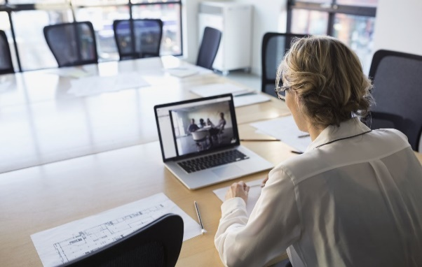
Video interviewing is a more convenient process for the candidate. If for no other reason than it reduces their travel time and adds flexibility for their attendance. But whilst on the face of it adds convenience, we should not overlook that using new technology can be a more daunting prospect for the interviewee. A couple of steps built into your interview procedures could help.
You may wish to offer a test call with the applicant prior to the interview. This would allow them to test the technology in a more relaxed state rather than minutes before an interview. A small offer but one that would be appreciated by individuals using your chosen video technology for the first time.
You may also wish to ensure all internal attendees have good working knowledge of the software being used.
Be available to help
When sending the interview invite recommend the interviewee log on to your video software 5 minutes before the scheduled interview time. This allows time to remedy any difficulties they may have.
Likewise, ensure one of your interviewers are tasked with logging onto the software a few minutes before the start of the interview. They can then test the audio and video quality and be available for any support the interviewee needs in connecting. It also allows a few minutes interaction that can act as a good icebreaker for the interview.
Consider having a Plan B available should the technology fail. May not be ideal but you could revert to an old-fashioned call so that the interview can at least proceed to some degree.
Awareness
Worth reminding all those attending to consider their location and background. Try to avoid areas where there will be movement or interruptions or using an office where other member of staff could enter. Make sure your phones are switched off and that emails are shut down to avoid interruptions or distractions.
Everybody’s body language gets magnified on video so ensure everyone brings the same energy level to each interview.
On the call
Two steps worth taking at the beginning of the call.
Take a few minutes at the outset to describe the etiquette of the call. This could be reminding all that unless speaking to remain on mute or how the message facility works and how you will use it.
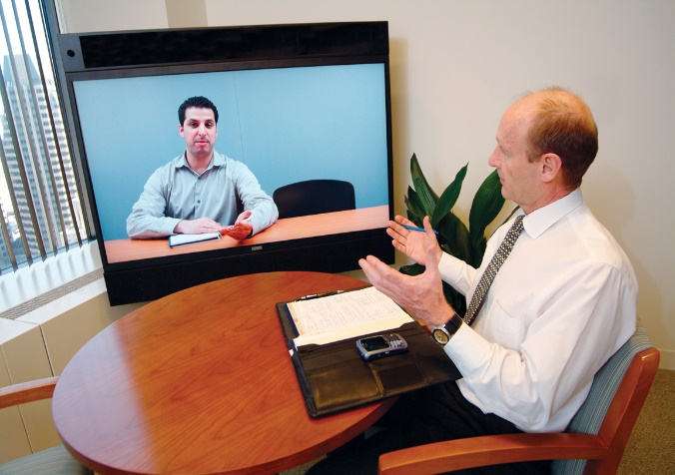
Spend a few minutes inviting all attendees to introduce themself and their role. Describe to the interviewee who will be asking the questions and who will be taking any notes.
Put the interviewee at ease. Assure them that you understand, and it is not a negative, if you hear a dog barking or a child in the background. That you all recognise that these are perfectly acceptable on an interview call.
If you are going to record the interview you should tell the candidate before the interview. Assuming you have, it obviously worth reminding the interviewee that you are doing so.
Roles on the call.
With video, you do not get the natural interactions you get with a face to face interview. To try to give the interview a flow and direction spend time prior to the interview preparing your questions and the flow of them.
Spend more time constructing and scripting the questions. Be clear on who is going to be asking the questions and leading the interview. It is a consideration that for the candidate several people asking questions on a video call can feel more intimidating than in a face to face environment. Do not forget to leave time for them to answer questions.
Be clear on how you are going to end the call. Share your timings and next steps so the interviewee is aware of your process. Perhaps someone other than the interviewer could wrap up the call.
Last thoughts
A couple of last thoughts.
Remember at the end of a video interview the interviewee is simply going to hit exit call. No opportunity for them to shake hands, no small talk back to reception, no emotive feeling from the interview.
Consider sending an email very quickly following the interview thanking them for their time, reiterating your process. Even better if you could personalise it with some reference to the interview.
We often ask candidates to present on interviews. If you still wish to do so, then make sure with your pre call that the candidate knows how to take the screen and to present. Perhaps you could suggest that the candidate emails it prior to the call. Either way it is going to be more challenging.
And finally, the business of recruitment will not stop because of recent events. But as we have seen, the process and format of interviewing has and will continue to change for both candidate and employer. We hope you found these tips of value and they help you as you change your processes.
If we can be of any help in your recruitment process, please do not hesitate to contact us.

